Spearman rank correlation: GBPUSD and USDCHF
Method 02 / daily log returns / Alpari D1 full available history

Study setup
Logical pair: GBPUSD , USDCHF
Broker symbols: GBPUSD_i , USDCHF_i
Snapshot: 2026-11-03_majors_alpari_D1
Timeframe: D1
Matched return window: 1999-01-05 to 2026-11-02 (UTC bar dates)
Matched return count n: 7201
Dropped unfinished last bar dated 2026-11-03 UTC after a tick-volume check against the prior complete day.
Complete matched rows (CSV): GBPUSD-USDCHF_Spearman_D1.csv
Complete matched rows (HTML table): GBPUSD-USDCHF_Spearman_D1_data.html

Method carried forward
Spearman rho is Pearson correlation on the ranks of matched daily log returns of close, ln(close_t / close_t-1), in the broker quote direction. Ties use average ranks. Quotes are not inverted. rho is symmetric under swap of the two symbols. rho = 0 means no consistent rank-order link in this sample; it does not mean no link of any kind. The score is not a cause, not a lead, and not a trading signal. Daily rows are not independent draws, so the two-sided p-value and approximate Fisher interval are reported and treated as secondary to rho. Same-sample Pearson r is shown only as a side check; a large rho minus r gap can flag outliers or a non-straight link.

Results
Spearman rho: -0.551519
Two-sided p-value: 0
Approximate 95% Fisher interval: [-0.567389, -0.535240]
Same-sample Pearson r: -0.486083
rho minus r: -0.065437

Conclusion
Over 7201 matched daily log-return rows for GBPUSD and USDCHF (broker quote directions unchanged), Spearman rho is -0.5515 (negative, moderate rank-order association in this sample). Approximate 95% Fisher interval: [-0.5674, -0.5352]. Same-sample Pearson r is -0.4861 (rho minus r = -0.0654). Two-sided p under the usual independent-ranks model is 0; that model does not match linked daily FX returns, so treat p as secondary. This does not establish cause, lead-lag, or a lasting trading rule.

Charts
Daily closes

Daily log returns
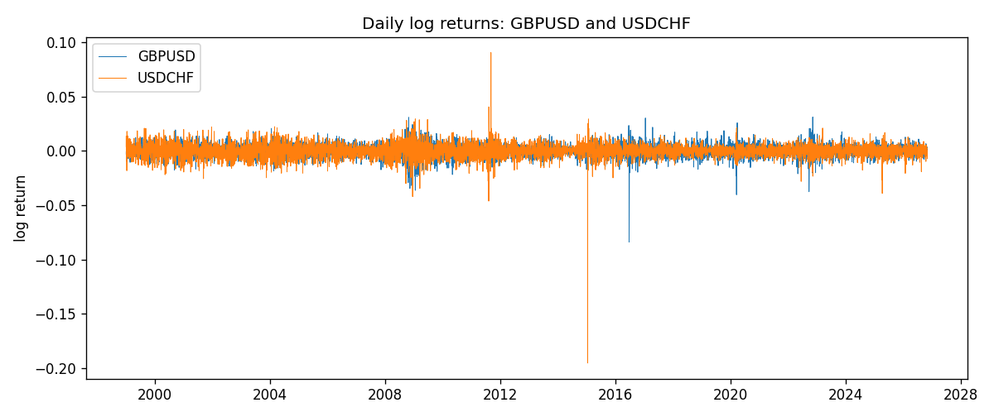
Log-return scatter
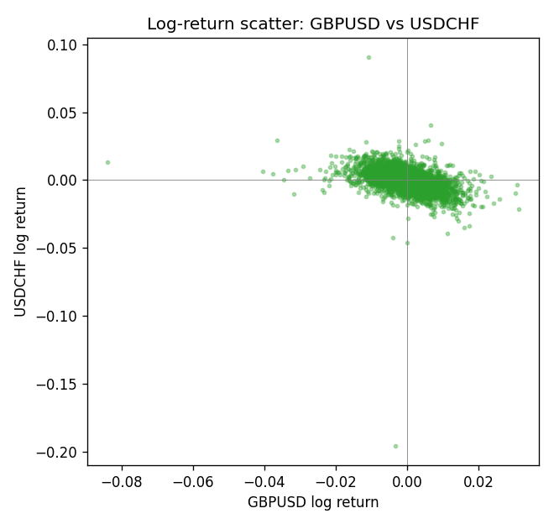
Rank-rank scatter
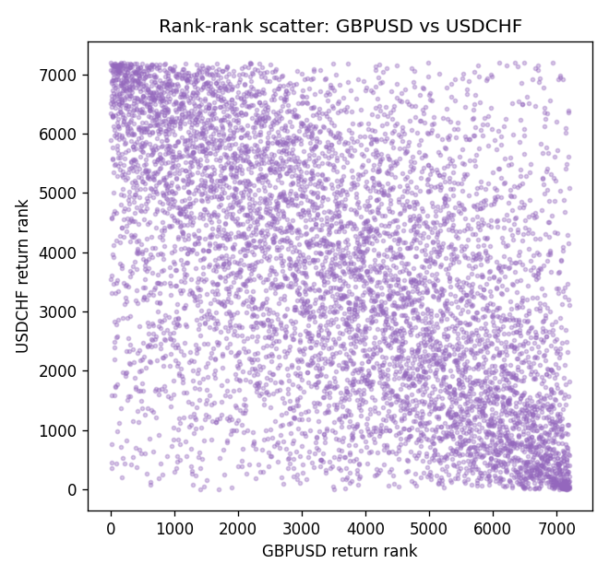

Data report
Every matched row that entered Spearman rho is stored in the sibling CSV named GBPUSD-USDCHF_Spearman_D1.csv. That file is the complete data archive for redrawing charts. Embedding all rows as a Word table is impractical at this length; the Word file holds the column list, column summaries, and the first and last 15 matched rows.
Columns: time, GBPUSD_open, USDCHF_open, GBPUSD_high, USDCHF_high, GBPUSD_low, USDCHF_low, GBPUSD_close, USDCHF_close, GBPUSD_tick_volume, USDCHF_tick_volume, GBPUSD_spread, USDCHF_spread, GBPUSD_real_volume, USDCHF_real_volume, GBPUSD_log_return, USDCHF_log_return
Column summaries (matched calculation rows)
column | count | mean | std | min | 25% | 50% | 75% | max
GBPUSD_open | 7201 | 1.5160785 | 0.218271 | 1.06854 | 1.32499 | 1.51142 | 1.63167 | 2.1066
USDCHF_open | 7201 | 1.0982956 | 0.25264095 | 0.72022 | 0.92069 | 0.99019 | 1.2387 | 1.8219
GBPUSD_high | 7201 | 1.5223771 | 0.21884011 | 1.08366 | 1.32979 | 1.5182 | 1.6384 | 2.1161
USDCHF_high | 7201 | 1.1035944 | 0.25438893 | 0.73305 | 0.92495 | 0.99377 | 1.2436 | 1.8313
GBPUSD_low | 7201 | 1.5097512 | 0.21749696 | 1.03518 | 1.31949 | 1.50336 | 1.6244 | 2.0983
USDCHF_low | 7201 | 1.0931703 | 0.25105533 | 0.08565 | 0.91742 | 0.9867 | 1.2331 | 1.8121
GBPUSD_close | 7201 | 1.5161456 | 0.2182303 | 1.06879 | 1.3251 | 1.5114 | 1.63212 | 2.1065
USDCHF_close | 7201 | 1.0982864 | 0.25254184 | 0.72025 | 0.92098 | 0.9902 | 1.2387 | 1.8217
GBPUSD_tick_volume | 7201 | 94828.085 | 153546.21 | 62 | 10002 | 52900 | 91806 | 1273370
USDCHF_tick_volume | 7201 | 74189.26 | 113409.95 | 18 | 12770 | 40195 | 70240 | 858589
GBPUSD_spread | 7201 | 26.971115 | 19.193539 | 0 | 11 | 20 | 50 | 50
USDCHF_spread | 7201 | 26.114567 | 24.723753 | 0 | 5 | 16 | 50 | 100
GBPUSD_real_volume | 7201 | 3.5560898e+09 | 8.4438214e+10 | 0 | 0 | 0 | 0 | 2.4038164e+12
USDCHF_real_volume | 7201 | 2.3236557e+10 | 8.9041498e+10 | 0 | 0 | 0 | 0 | 1.9331921e+12
GBPUSD_log_return | 7201 | -2.316e-05 | 0.00564524 | -0.08388241 | -0.00312969 | 3.242e-05 | 0.00318104 | 0.03112653
USDCHF_log_return | 7201 | -7.148e-05 | 0.00659332 | -0.19545699 | -0.00335964 | 8.06e-05 | 0.00331782 | 0.09051364
First 15 matched rows (selected columns)
time | GBPUSD_close | USDCHF_close | GBPUSD_log_return | USDCHF_log_return | GBPUSD_tick_volume | USDCHF_tick_volume
1999-01-05 | 1.6547 | 1.3724 | -0.0028966287 | 0.0039424743 | 4645 | 4666
1999-01-06 | 1.6537 | 1.3912 | -0.00060452184 | 0.013605652 | 4729 | 3740
1999-01-07 | 1.6502 | 1.3782 | -0.002118709 | -0.0093883841 | 4858 | 4262
1999-01-08 | 1.6405 | 1.3935 | -0.0058954193 | 0.011040268 | 5354 | 5991
1999-01-11 | 1.6312 | 1.4009 | -0.0056851331 | 0.0052963193 | 4080 | 5236
1999-01-12 | 1.6349 | 1.3872 | 0.0022657001 | -0.0098275602 | 5001 | 5975
1999-01-13 | 1.6499 | 1.3621 | 0.0091330396 | -0.018259701 | 5730 | 7036
1999-01-14 | 1.6531 | 1.3588 | 0.0019376331 | -0.0024256692 | 4902 | 5825
1999-01-15 | 1.6502 | 1.3834 | -0.0017558204 | 0.01794228 | 6383 | 7434
1999-01-18 | 1.6522 | 1.379 | 0.0012112405 | -0.0031856384 | 4357 | 4965
1999-01-19 | 1.6553 | 1.3789 | 0.0018745281 | -7.2518946e-05 | 4655 | 5494
1999-01-20 | 1.6472 | 1.3889 | -0.0049053846 | 0.0072259871 | 4502 | 5477
1999-01-21 | 1.6524 | 1.3836 | 0.0031518998 | -0.0038232689 | 4609 | 4736
1999-01-22 | 1.6565 | 1.3834 | 0.0024781662 | -0.0001445609 | 4230 | 4833
1999-01-25 | 1.6585 | 1.3868 | 0.0012066366 | 0.0024546976 | 3069 | 3996
Last 15 matched rows (selected columns)
time | GBPUSD_close | USDCHF_close | GBPUSD_log_return | USDCHF_log_return | GBPUSD_tick_volume | USDCHF_tick_volume
2026-10-13 | 1.32534 | 0.83244 | 0.0036434319 | -0.0024955621 | 53930 | 32763
2026-10-14 | 1.31884 | 0.83489 | -0.0049164679 | 0.0029388325 | 64640 | 40903
2026-10-15 | 1.32757 | 0.82676 | 0.0065976411 | -0.0097855323 | 80461 | 54132
2026-10-16 | 1.33257 | 0.82377 | 0.0037592051 | -0.0036230826 | 65988 | 47176
2026-10-19 | 1.33024 | 0.82677 | -0.0017500314 | 0.0036351779 | 56543 | 40610
2026-10-20 | 1.3377 | 0.8246 | 0.0055923442 | -0.0026281224 | 58955 | 42106
2026-10-21 | 1.33937 | 0.82427 | 0.0012476328 | -0.00040027413 | 55613 | 37648
2026-10-22 | 1.33967 | 0.82032 | 0.00022396082 | -0.0048036381 | 64255 | 50809
2026-10-23 | 1.33684 | 0.82497 | -0.0021146949 | 0.005652514 | 58068 | 45872
2026-10-26 | 1.33359 | 0.82649 | -0.0024340661 | 0.0018407959 | 56434 | 41336
2026-10-27 | 1.33044 | 0.82865 | -0.0023648393 | 0.0026100526 | 54846 | 35560
2026-10-28 | 1.33254 | 0.82781 | 0.0015771808 | -0.0010142111 | 61264 | 42431
2026-10-29 | 1.33733 | 0.82379 | 0.0035881935 | -0.0048680164 | 71194 | 53780
2026-10-30 | 1.33913 | 0.82438 | 0.0013450605 | 0.00071594559 | 70446 | 55459
2026-11-02 | 1.3406 | 0.81851 | 0.0010971256 | -0.0071459744 | 60471 | 45329

